Red Hill Christian School
Erin Decker, Administrator
Lisa Nase, Office Manager
lnase@redhillchristianschool.org
Marti Moffett, Family & Staff Director
mmoffett@redhillchristianschool.org
Angie Monaghan, Operations Director
amonaghan@redhillchristianschool.org

215.679.6613
www.redhillchristianschool.org

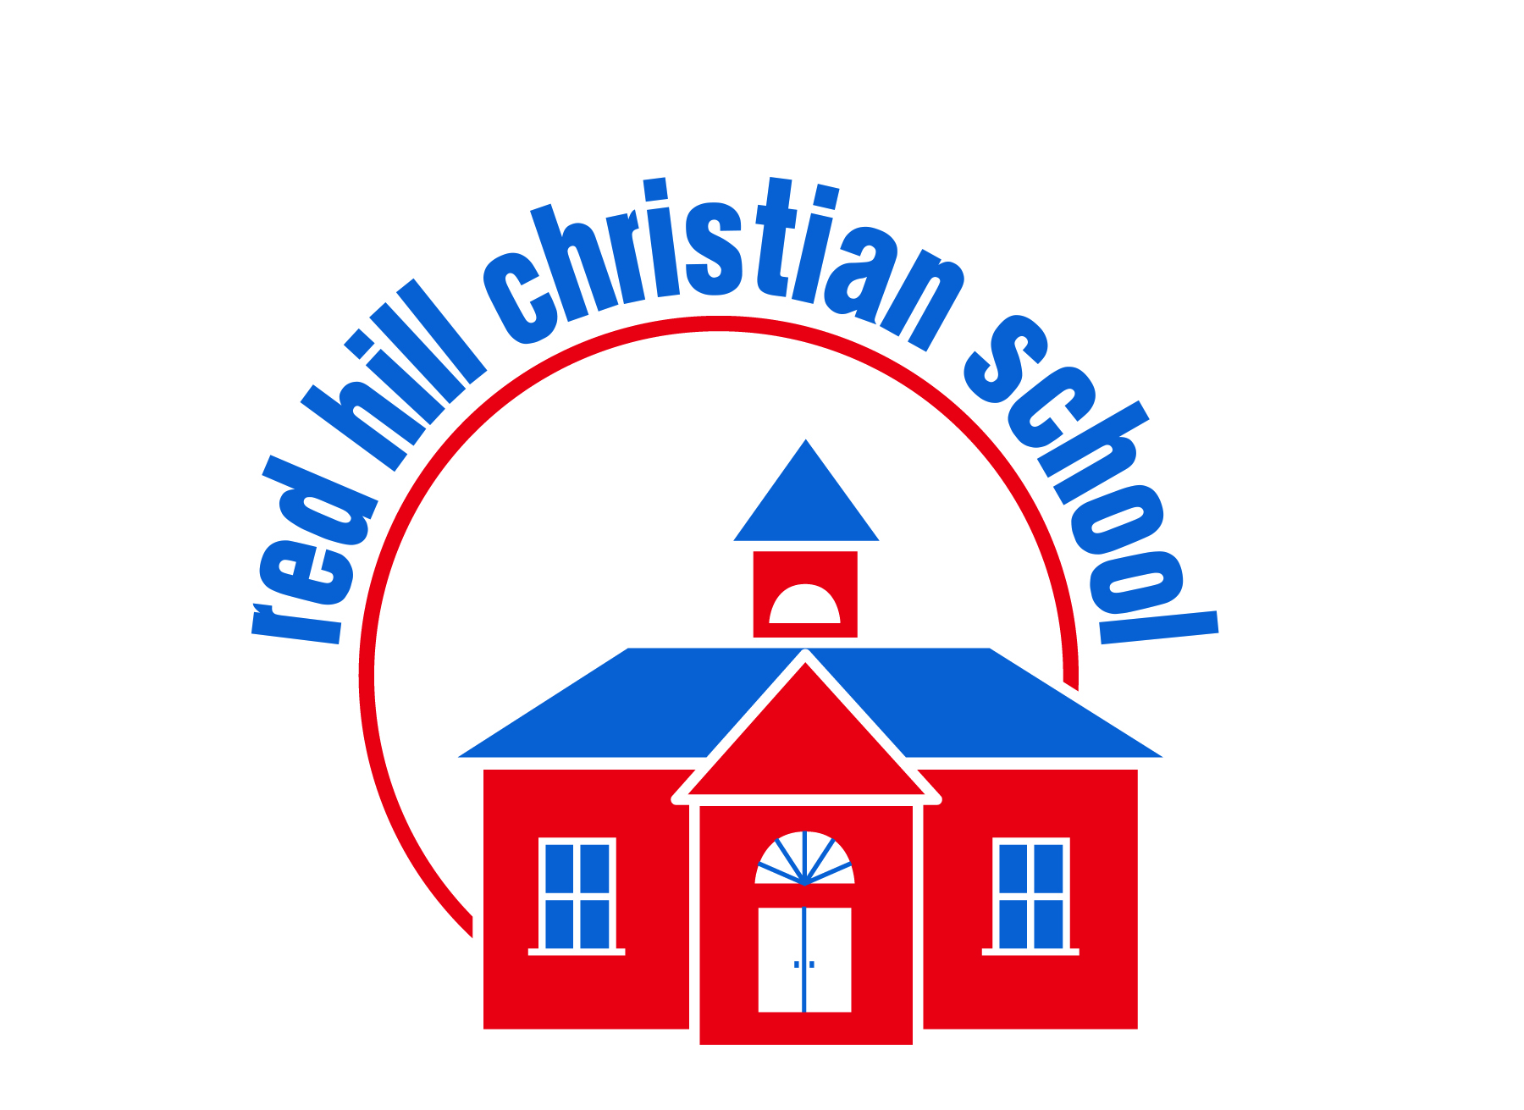

RED HILL CAMPUS CHILD CARE
2022 – 2023

208 East 5th Street
Red Hill, PA 18076

Aug 29 |  |  | Mon | Upper Perkiomen School District (UPSD) First Day of School  1st Day of 2022-23 School Year
Sept 2 |  |  | Fri | UPSD Closed / RHCS Child Care Open
Sept 5  Sept 16  Sept 16 |  |  | Mon  Fri  Fri | Labor Day - UPSD & RHCS Closed  UPSD 3 hr. Early Dismissal  Campfire Night @ Green Lane Park 6-8 pm
Oct 10–14  Oct 10  Oct 21  Oct 31 |  |  | Mon-Fri  Mon  Fri  Mon | Fire Prevention Week  UPSD Closed / RHCS Child Care Open  UPSD 3 hr. Early Dismissal  Pumpkin Parties
Nov 8  Nov 18 Nov 18  Nov 21-23  Nov 24, 25 |  |  | Tues  Fri  Fri  Mon-Wed  Thurs, Fri | UPSD Closed – Child Care Open  Grandparent’s Day  UPSD 3 hr. Early Dismissal / RHCS Child Care Open  UPSD Closed / RHCS Child Care Open  Thanksgiving Holiday - UPSD & RHCS Closed
Dec 23  Dec 26-31  Dec 26 |  |  | Thurs  Mon-Fri  Mon | UPSD 3 hr. Early Dismissal  UPSD Closed - Winter Break  Christmas Holiday - RHCS Closed
Dec 30 |  |  | Fri | RHCS Closed at 4pm
Dec 27–30 |  |  | Tues-Fri | RHCS Child Care Open
Jan 2  Jan 16  Jan 27  Feb 14  Feb 17  Feb 20  March  Mar 17  Apr 6-10  Apr 7  May 16  May 29  June 7 – 9  June 12  June 19  July 4 |  |  | Mon  Mon  Fri  Tues  Fri  Mon  All Month  Fri  Thurs-Mon  Fri  Tues  Mon  Wed-Fri  Mon  Mon  Tue | New Year Holiday – RHCS Closed  MLK Day – UPSD Closed / RHCS Child Care Open  UPSD 3 hr. Early Dismissal / RHCS Child Care Open  Valentine’s Day Parties  UPSD Early Dismissal / RHCS Child Care Open  President’s Day - UPSD Closed / RHCS Closed (Teacher In-Service Day)  Art Fair at UPV Library in Red Hill  UPSD Early Dismissal / RHCS Child Care Open  UPSD Closed Spring Break / RHCS Child Care Open  UPSD & RHCS Closed Good Friday/Easter  UPSD Closed / RHCS Child Care Open  Memorial Day / RHCS Closed  UPSD 3 hr. Early Dismissal  UPSD Last Day of School Year / Early Dismissal  First Day of Summer Camp 2022  July 4^{th Holiday} / RHCS Closed  Please Note: Calendar schedule is according to the current information from UPSD and may be changed according to the school district’s discretion. Additional RHCS family activities and events will that are scheduled will be confirmed and calendar will be updated accordingly. Thank you for your patience and understanding.
Winter Weather Advisory

In case of hazardous weather conditions, please note the following:

- If Upper Perkiomen School District is CLOSED, in most cases, Child Care will remain OPEN, but may begin late.

- If Upper Perkiomen School District has a 2 hour delayed start, we are normally open regular hours, 6:30am – 5:30pm. Childcare will remain OPEN, but may begin late.

- Check RHCS Facebook page for Weather related delays, early closing, and closed information. Weather related information will be sent through your child’s teachers form of teacher/parent communication such as, Brightwheel, Shutterfly, or private class Facebook page.

- If a storm begins during the school day . . . PLEASE allow ample drive time to arrive before 5:30pm so our staff can go home safely.

Look for teacher information on your child’s monthly calendar for when classroom events, field trips, and special activities are scheduled.

** Childcare provided and RHCS childcare open every day except:

Sept 5 Nov 24, 25 Dec 26 & Jan 2 Feb 20 April 7 May 29 July 4

8/5/2022

